Online Learning Experience
Ashlee R. Crawford
Kennesaw State University
Designing Online Learning—ITEC 7481
Fall 2015
Dr. Julia Fuller

Overview
In the module that I have chosen to teach, the students will be learning about force and motion. The students will focus on 3 of the standards in that Unit. The standards are that students should be able to describe the relationship between velocity and acceleration, demonstrate the effects of balanced and unbalanced forces on objects, and recognize that every object exerts a gravitational force on other objects that depends on the mass and the distance of the objects. All the standards can be found under 8th Grade Science at www.georgiastandards.org. By the end of the all lessons within the module students should be able to describe the relationships between velocity, acceleration, and speed. Student should also be able to demonstrate, tell the difference between and give examples of balanced and unbalanced forces. Lastly students should be able to prove and explain how objects exert gravity on each other and how distance and mass plays an integral part on the gravitational pull between the objects. This module will be implemented with 8th Grade Physical Science Students in an inclusion setting.
Context
This online experience will be a hybrid experience. Essentially the way this lesson is set up I would love for it to be totally online with only face to face synchronous sessions. Due to the fact that I teach at a Title I School, its majority African American, majority living at poverty level, and therefore technology at home is extremely limited, most of the experience will be completed at school. At the school where I teach, Thomson-McDuffie Middle School (T-MMS), technology is in abundant supply. We have 4 iPad carts, 5 Chromebook Carts, and 5 computer Labs. I will use all of the above resources to make it fill like they are doing their work online and still hold a synchronous session once a week. They will just work on it at school at their own pace. Hopefully this will give the feel of a total online experience. Students all know how to use all the tools necessary to complete the modules and therefore I feel that they will be very successful with the entire experience. The only technical requirement is Google and Internet Access. Students already have their Google e-mail addresses and passwords. Internet access and Wi-Fi (for tablets and laptops) is provided by the school.
Assessment Practices
In the module that I have setup there are both formative and summative assessments. The formative assessments such as the discussion posts and PowerPoint Notes Questions are there so I can check your understanding. Students will get feedback if the information in the formative assessment does not look right. The Simulations and the Quizzes are summative and the data can be used to see if re-teaching is needed on the standards after the unit is complete. All Simulations will have feedback and if the student did not get the grade they believe they deserve they will be able to resubmit their simulations with corrections for a better grade. The summative and formative assessments will be directly linked to the standards and mastery will be shown by the score the student receives on the assignment. Growth will be shown by looking at the students Pre-Test Scores and comparing them to the student’s Post Test Scores.
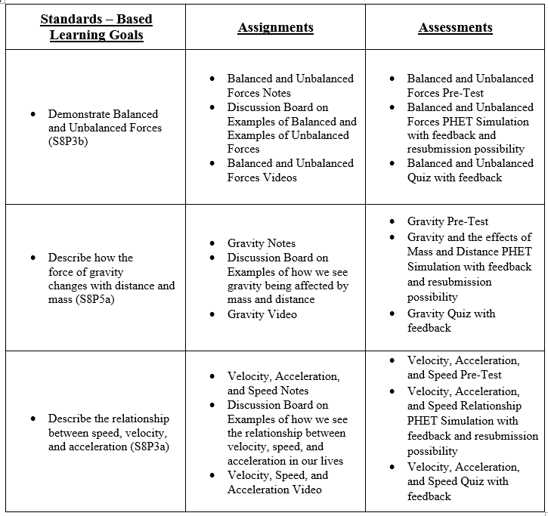
Accommodations
I teach in an inclusion setting so accommodations for the students have to be made. Students can work at their own pace. I will also allow SPED students to have peer helpers. These are individuals that are exceeding and have volunteered to help other students. This is especially important for the simulations since they are more difficult and take more time and way deeper thought. All Quizzes will be read aloud. If this was true all the way online experience than a voki widget or voice thread would be a great tool to add to Haiku Learning so that students can have their quizzes read aloud. Also I have provided learning videos that are below grade level but still have the content. These are for the students who need something that is a little easier to understand. Fill in the blank notes and questions can be provided in extreme cases. Also students with 504 plans will be accommodated with the accommodations mentioned above.
Accessibility
The module is ADA complaint and accessible. Haiku Learning e-mailed me back and made a brief statement that they are ADA complaint. Since this will be done in a non-online school most of the students work will be done at school in a school like online setting. This will ensure equitable access to all students that I am currently teaching. Which is very important because this ensures that all learners have the opportunity to learn the content. Especially since my school is not really an online school. Keyboards are available when using iPads. Like mentioned on my Haiku Learning if specific accommodations need to be made they can be addressed to me and I will get what the student needs. Also accessibility and compliance is met because of multiple representation of the content and the fact that students are working at their own pace in their own little world or small group (when needed).
Differentiation
In the online module that I have created students get the chance to have differentiation in many ways. Students experience differentiation by having multiple forms of expression, engagement, and representation. Multiple forms of representation include Webpages, Labs, Rap Songs, Videos, and PowerPoint. Multiple forms of expression include Discussions, Quizzes, Lab Reports, Learning Task Handouts, and other various Writing Assignments. Multiple forms of engagement include Computer Simulations, Group Activities, and In-Class Synchronous Sessions. All of these things ensure that every child is engaged and learning. Also if students need Peer buddies or Fill in the Blank notes, these will be provided when necessary.

